HELLO WORLD APP DOCUMENTATION
PLATFORM
Android (Flutter Framework)
DEVELOPMENT ENVIRONMENT
- Flutter SDK
- Android Studio
- Dart Programming Language
Installing android studio
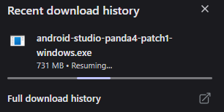
Install flutter
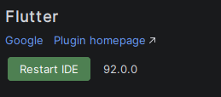
Unzip flutter SDK

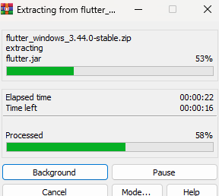
Setting up flutter
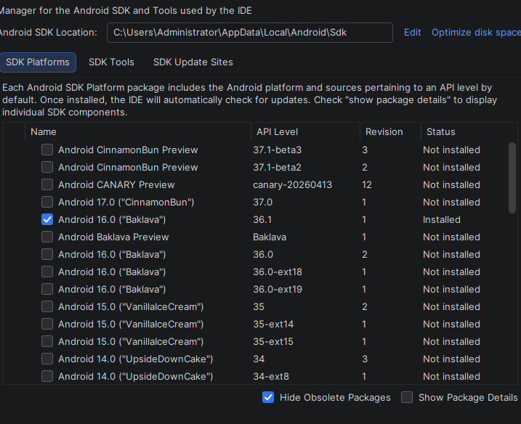

Retrieving flutter
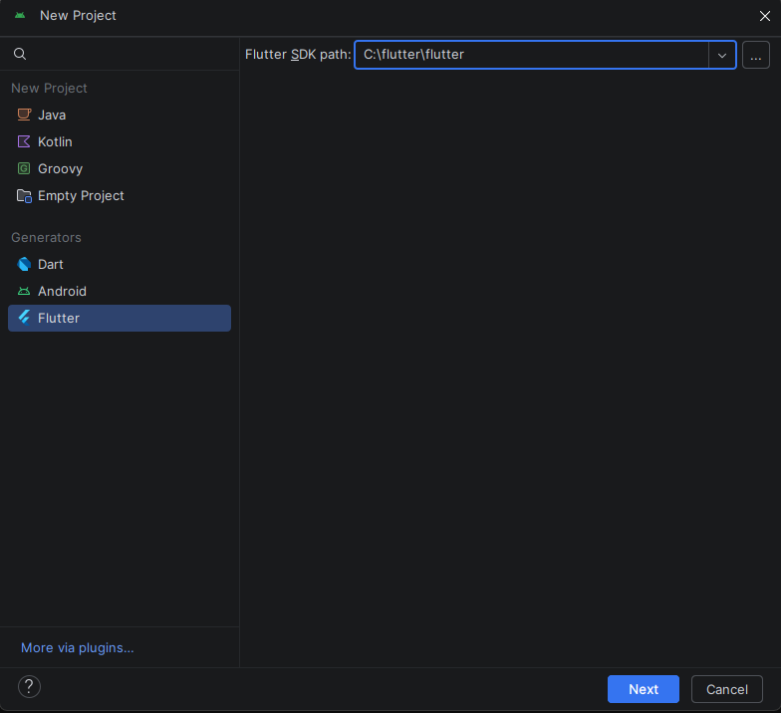

Code running
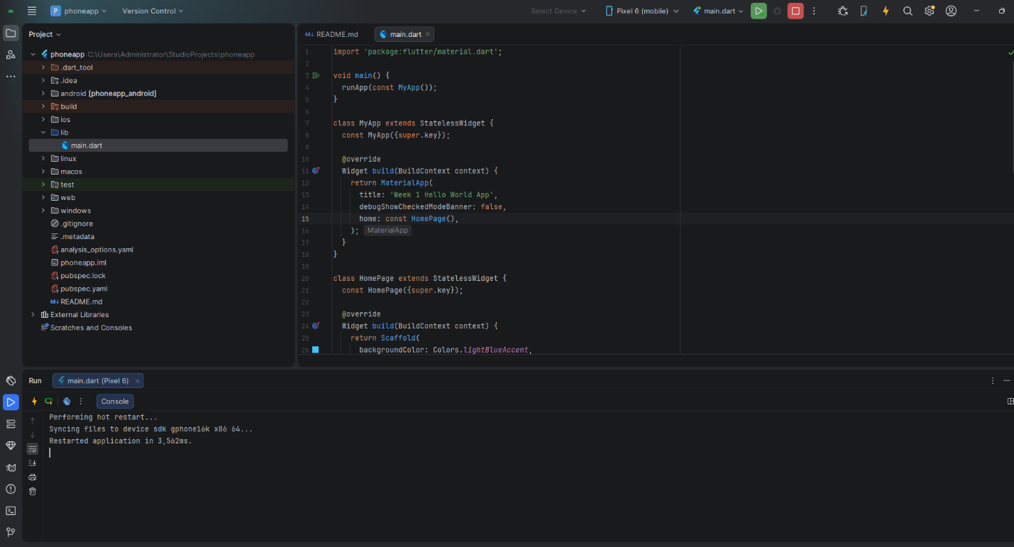
CODE (Dart)
This imports Flutter's Material Design library, which provides widgets such as MaterialApp, Scaffold, Text, AppBar, and ElevatedButton.

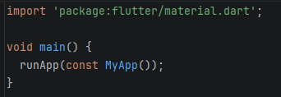
Sets up the whole app structure
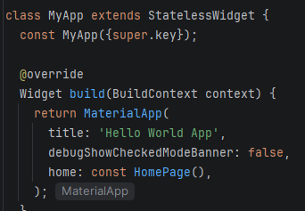
Creates the main screen of the app
Stateless → screen does not store changing data
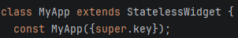
Shows a pop up message
showDialog() → opens a popup window
AlertDialog → styled popup box
content → message text
TextButton → closes popup
Navigator.pop() → removes dialog from screen

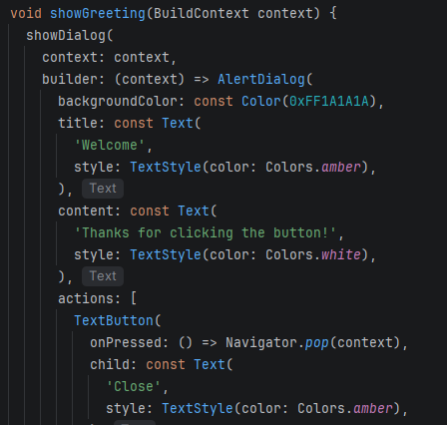
Builds page UI layout
Scaffold – page structure container
Layout – how everything is arranged

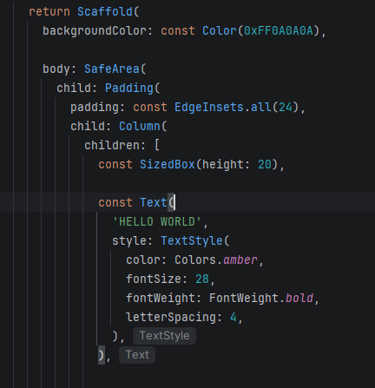
creates a glowing circular centerpiece with a large globe icon in the middle

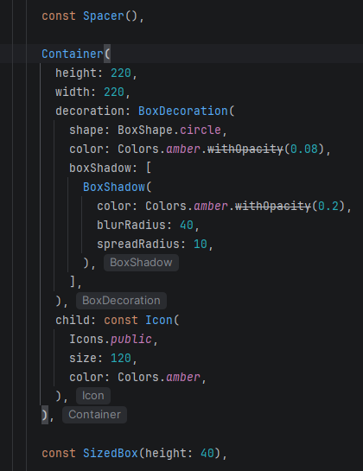
displays a title, a short description, and a large rounded GET STARTED button that shows a popup message when tapped.

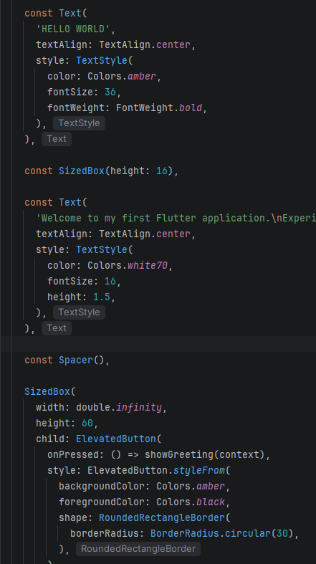
displays the "GET STARTED" text inside the button
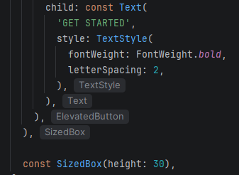

App running
